|  |  |  |  |  |
| --- | --- | --- | --- | --- |
| 2000px-IUST_logo_solid_black2.png |  | **Automotive Science and Engineering**  **Journal Homepage: ase.iust.ac.ir** |  | C:\Users\Research Asistant\Dropbox\PC\Desktop\main_en.png  ISSN: 2008-9899 |
|  |

**Elman and Jordan neural networks for prediction of transient thermal contact for engine exhaust valve**

**Mohsen Motahari-Nezhad**

Department of Mechanical Engineering, Technical and Vocational University (TVU), Tehran, Iran,

|  |  |  |
| --- | --- | --- |
| **ARTICLE INFO** |  | **A B S T R A C T** |
| **Article history**:  Received : 15 Nov 2022  Accepted: 17 Jan 2023  Published: 3 Mar 2023 |  | In this study, feedback neural networks namely Elman and Jordan are used for prediction of exhaust valve temperature for air cooled engines. Input-output data are extracted from an experimental setup including the valve mechanism of an air cooled engine. Inverse heat transfer problem applying the Adjoint problem is used to address the thermal flux through exhaust valve and seat. Elman and Jordan neural networks are used to predict the transient valve temperature using the experimental data. The results show that Elman and Jordan neural networks predicts well the transient exhaust valve temperature. However, Jordan neural network with training algorithm of Gradient Descent with Adaptive Learning Rate performs better with RMSE error of 16.3 for prediction of exhaust valve temperature. | |
| **Keywords**:  Elman  Jordan  Feedback network  Exhaust valve  Air cooled engine |

**1.Introduction**

Exhaust valves are of important parts in internal combustion engines. Also, heat transfer problem in exhaust valve is from practical issues in heat transfer applications. So, prediction of temperature transfer function between exhaust valve and seat is very important. Precise defining of this parameter helps the engineers to decide the best materials in designing different parts of industrial engines. Also, to consider the required considerations in designing the cooling system of the engines. In this regards, the problem of heat transfer through valve and seat always attracted the attentions of researchers in the related fields.

Experimental investigations have been widely used for prediction of thermal contact within valve and seat. Mohamed Hassan et al. investigated the heat flux enhancement through valve and seat using engine thermal simulation. They indicated that the materials of beryllium, bronze-copper and brass for seats of the valves will enhance total heat transfer about 4.16%, 2.06%, and 4.46%, respectively, in comparison with the sintered iron [1]. Cerdoun et al. carried out a research to show the heat flux through exhaust and intake valves for different engine speeds. Their model was applied to capture the temperature distribution for intake and exhaust valves considering the various working conditions [2]. Shojaeefard et al. have experimentally analyzed transient temperature of the exhaust valve for an engine. A procedure was extended for transient heat transfer investigation of the engine exhaust valve [3]. Cerdoun et al. investigated the non-steady heat flux of engines’ exhaust valves. Their results indicated that the coefficient of heat transfer is of the main issues in the valve-seat region [4]. Prasad et al. investigated heat transfer of exhaust valve using thermal barrier material. In their study, temperature and heat flux variation were studied against thermal barriers [5]. Abdollahi et al. have conducted a review study for studying the effective parameters on thermal contact [6]. Shojaeefard et al. conducted a research on the impact of the number of contact on thermal contact. They indicated that the TCC decreases with increasing the contact frequency [7]. Motahari-Nezhad et al. have investigated the importance of various parameters on contact heat transfer. They indicated that between different parameters, the contact pressure has more impact on contact heat transfer. Then, the contact frequency is the next important parameter [8]. Hassan et al. investigated the effect of heat transfer through seat and valve on engine performance using steady-state thermal simulation [9]. Motahari-Nezhad et al. studied the transient heat flux through the engine valve and its seat by the inverse problem [10].

Recently, numerical studies have been used for TCC estimation between valve and seat using finite element and finite volume methods. Hassan et al. investigated the impact of enhancing heat flux through seat and valve on engine performance using numerical simulation. In their study, the valve seat made of brass indicated the highest rate of heat absorbance [11]. Al-Baghdadi et al. investigated the impact of thermal coatings of exhaust valve on thermal and mechanical stresses in diesel engine applying a finite-volume method (FVM). Results indicated that thermal coating decreased the von-Mises stress distribution and temperature distribution [11]. Cerdoun et al. carried out a research on the heat flux between engine’s valves and seats for different engine speeds using finite element method. Their paper concerned a study of the coefficient of heat transfer at different engine rotation and the temperature variation within intake and exhaust valves [12]. Rao et al. applied ANSYS software to investigate the effect of using composite Titanium Nitrite (TiN) as a coating on engine exhaust valve. It was found that Titanium Carbide and Titanium Nitride as coatings can enhance the valve performance [13]. Pavel et al. have applied the finite element method to investigate the temperatures on the engine valves and seats. Their study explained the temperature distribution on the valves and seats of the internal combustion engines [14].

Data-driven methods are powerful tools for most complicated problems including thermal contact in internal combustion engines. Motahari-Nezhad et al. developed a neuro-fuzzy algorithm to estimate contact heat flux within valve and seat. It was indicated that neuro-fuzzy algorithm can predict the thermal contact through the seat and valve well using of input and output data [16]. Fathi et al. investigated the application of feedforward neural networks and fuzzy model to predict thermal contact through contacting bodies. They indicated that between various algorithms, ANFIS has the least error for prediction of TCC through contacting bodies [17]. Goudarzi et al. studied applying feedforward neural networks to the problem of estimating the TCC within engine exhaust valves. In their study Multi-Layer Perceptron (MLP) model has been applied to estimate the contact heat transfer through the seat and valve. Their results showed that, among the various models, Levenberg Marquardt has the best performance for prediction of the target parameters [17].

By literature review, feedforward neural networks have been previously used for estimating the contact heat transfer though seat and exhaust valve. However, feedback and newly introduced neural networks have not been applied and compared for this purpose. So, in this study, first, the temperature distribution within the seat and exhaust valve are extracted using an appropriate experimental investigation and by applying the inverse problem, the coefficient of contact heat transfer is measured. Then, the temperature values of seat and valve are considered as input and the coefficient of contact heat transfer as output data to predict the temperature transfer function through exhaust valve using Jordan and Elman neural networks.

**2. Experiments**

In the [resent study, we have used from the data extracted from an experimental study on contact heat transfer carried out by Motahari Nezhad et al. [10] as the required data for extending the model. The cylinder head of engine Wave 125 is considered in experiments. In the experiments, the cartridge heater is utilize for heating the valve. The test apparatus consists a part of an air-cooled engine. The experimental apparatus has two main section: mechanical and electrical parts. An electric motor is used for rotation of the cylinder engine camshaft. The experimental test setup can be found in Figure 1. Figure 2 indicated the installation of thermocouples and heater inside the engine cylinder head. A wind tunnel is used for cooling the cylinder head of the engine. In this research, K-type thermocouples with a diameter of 1 mm were used for data recording. This thermocouple works well in −40 ◦C to 1000 ◦C. Four thermocouples are used in the tests. The test are carried out under non-fixed contacts condition under the rotation speed of 210 rpm. More detailed description could be accessed in ref. [10].

The experiments carried out in the environmental condition. The temperature data were captured by starting the test until a quasi-steady state condition. In experiments, a quasi-steady state is described as the condition in which the temperature for two subsequent cycles of n and n+1 becomes the same. In the tests, the heater start working when the data recording starts and the cooling blower starts working. Throughout the experiment, there is a uniform heat flux applying to the exhaust valve. After that the quasi-steady state is created, the data logger stops the temperature data collection. More descriptions of the test equipment could be reached in ref. [10].

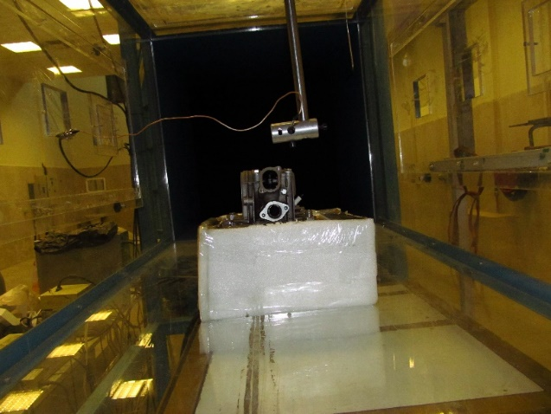

Figure :Test setup

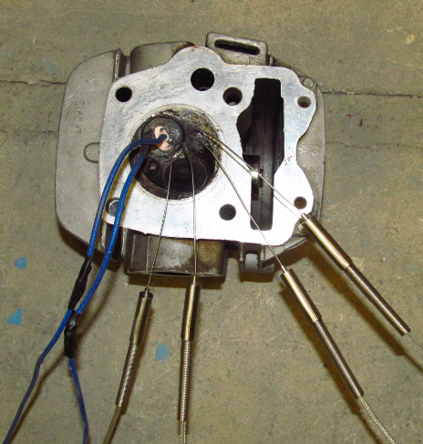

Figure :Thermocouples and heater installation [10]

**3-Theoretical background**

**3-1-** **Inverse method**

The issues of heat transfer can be direct or inverse problems. In direct issues that have more applications, geometry, initial and boundary conditions, and thermos-physical properties are known. The goal in these problems is to calculate the temperature inside the solution area. In reverse heat transfer problems, some of this information are unknown, and instead additional information, usually measured temperatures inside the solution zone or at the boundary, are known. In this study, according to the conditions and limitations of the problem of estimating the TCC, the conjugate gradient method has been applied to resolve the inverse heat transfer problem.

Figure 3 shows the geometry and coordinates of the problem. The boundary condition is that at one end of the seat the temperature varies with time and the center of the valve receives a uniform heat flux. It is assumed that the number of contacts between the valve and the seat is such that stable conditions can be considered to obtain the temperature distribution along them. The mathematical formula for heat transfer is as follows:

Valve seat:

|  |  |  |
| --- | --- | --- |
|  | For t>0  in *0 < x < L1* | (1) |
|  | For t>0  at *x = 0* | (2) |
|  | For t>0  at *x = L1* | (3) |
|  |  | (4) |

Exhaust valve:

4054

|  |  |  |
| --- | --- | --- |
|  | For t>0  in *L1< x < L2* | (5) |
|  | For t>0  at *x = L1* | (6) |
|  | For t>0  at *x = L2* | (7) |
|  |  | (8) |

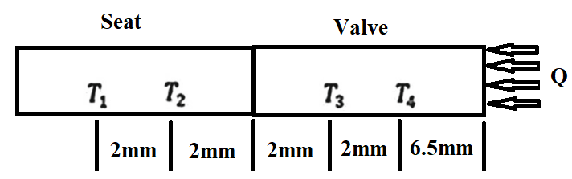

Figure :One dimensional model for thermocouples location inside the contacting bodies

**Method of solving the inverse heat transfer problem**

For solving the inverse conduction problem, the TCC (h (t)) is considered unknown while other effective quantities are known. Also, the exhaust valve and seat temperatures are measured at the appropriate points. According to Figure (3), we assume that there are two sensors in exhaust valve and two sensors in the seat. Temperatures are measured at ti times (i = 1, 2,…, I).

The temperatures captured using the sensors can be shown as below:

|  |  |
| --- | --- |
|  | (9) |

We suppose that at first there is no initial knowledge of h (t). We look for h (t) through a period of time and suppose that h (t) is from the Hilbert space, which can be described as following:

|  |  |
| --- | --- |
|  | (10) |

Solving the problem would be done considering that the equation (11) is minimized:

|  |  |  |  |
| --- | --- | --- | --- |
|  | | (11) | |
|  | |  | |

Which and  are the predicted temperatures in the desired coordinates. The principal procedure for the mentioned algorithm is minimizing the equation (11).

**Stop criteria**

In the minimization procedure of S [h (t)], when the predicted temperatures nearly equals to the real temperatures, which also have an error, large fluctuations may appear in the inverse problem solving. By using the stop criterion, the possibility of this deviation will be reduced. The stop criteria can be described as:

|  |  |
| --- | --- |
|  | (12) |

Which ε is a small number.

**3-2-Moving Average Filter**

Before training the neural networks, thermal contact conductance calculated by inverse method are averaged using a Moving Average Filter (MAF). It is indicated with following equation:

|  |  |  |
| --- | --- | --- |
| (13) |  | $$y\left(m\right)=\frac{1}{K}\sum_{i=0}^{K-1}{x(m-i)}$$ |

Here $x(m)$ represents the sample for an input signal and $y(m)$ represents the output.

**3-3-Accuracy index**

We compare our methods by the metric of Root Mean Squared Error (RMSE) which is formulated using the following equation:

|  |  |
| --- | --- |
| $$RMSE=\sqrt{\frac{1}{n}\sum_{i=1}^{n}{{({\hat{x}}_{i}-{\overline{x}}_{i})}^{2}}}$$ | (14) |

In which n represents the number of observations, ${\hat{x}}_{i}$ and ${\overline{x}}_{i}$ represents the ground truths and predicted values respectively.

**3-4-Jordan and Elman Feedback neural networks**

The Jordan network is similar to a feedforward one which has a hidden layer, except that it is developed by context units (Figure 4). The outputs are sent into the context units and then into the hidden layers. In addition, the context units have their own signal connection, thus allowing the network to recall actions taken in the past. The Elman network is a simplified structure of the Jordan network. In this network, each hidden node has a self-connecting return signal (Figure 5).

4055

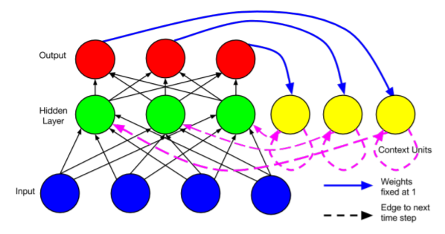

Figure :Jordan neural network [19]

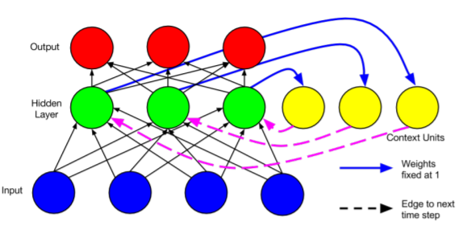

Figure :Elman neural networks [19]

**4-Results and discussion**

The experimental surface temperatures data obtained from the start of the test until quasi steady conduction for periodic and fixed contact with a speed of 210 rpm can be found in Figures 6 (a) and 7 (a), respectively. Also, the contacting surface temperatures of the seat and exhaust valve by applying the linear extrapolation method based on the geometry of Figure 3 for periodic and fixed contact with a speed of 210 rpm can be found in Figures 6 (b) and 7 (b), respectively. By applying the inverse method, TCC has been calculated for fixed and periodic contact as their changes versus time can be shown in Figures 8 (a) and 9 (a), respectively. Before training the neural networks, TCC changes over time is averaged using moving averaged filter and the results for fixed and periodic contacts can be depicted in Figures 8 (b) and 9 (b), respectively.

|  |
| --- |
|  |
| Figure : Measured sensors temperatures b) Contacting surfaces temperature |

|  |
| --- |
|  |
| Figure : a) Measured sensors temperatures b) Contacting surfaces temperature |

4056

|  |
| --- |
|  |
| Figure : a) TCC b) Average of TCC (Fixed contact) |

|  |
| --- |
|  |
| Figure : a) TCC b) Average of TCC (Periodic contact) |

Thermal management of exhaust valves in internal combustion engines are crucial due to their high temperature during engine working especially in full loads. Exhaust valves are mainly cooled by periodic contact with engine cylinder head seats through the engine cooling system. In this study, investigation are carried out to estimate exhaust valve temperature using feedback neural networks namely Elman and Jordan based on existing data of seat temperature and TCC between valve and seat. Neural networks inputs and outputs are presented in Table 1. Neural networks are trained for estimation of the temperature of the exhaust valve using exiting data of seat temperature and TCC. So, the networks are trained with two inputs of seat temperature and TCC through seat and valve. The temperature of the exhaust valve is the only output of the networks and the networks are trained with two inputs and one output. Average of the results of TCC calculation obtained by applying moving average filter is used in training and testing the networks. During the training process, the minimum values for the Elman and Jordan networks were obtained for the number of hidden layer neurons equals to 12 and 10, respectively. The data of tests for fixed and periodic contacts are used for training and testing the networks, respectively.

Table :Network inputs and output

|  |  |
| --- | --- |
| **Parameter** | **Variable** |
| Network inputs | Seat Temperature, TCC |
| Network output | Exhaust valve temperature |

Tables 2 indicates performance of different training algorithms for Jordan and Elman networks. As it is visible from the Table, the Gradient Descent with Adaptive Learning Rate has the best results for the Jordan with RMSE error of 16.3 and the resilient method has the best performance for the Elman network with RMSE error of 28.3. The results of the best algorithms are bolded in this Table. The training error curves for the best model of Elman and Jordan networks are depicted in Figures 10 and 11, respectively, in terms of the number of repetitions. As can be seen, for both curves, the error rate suddenly decreases in the initial iterations. This represents model training by input data. The error rate is then reduced to a lesser extent. Figure 12 shows the comparison for the results of exhaust valve temperature prediction using Jordan and Elman networks with the best training algorithms. It is show that Jordan neural networks has the best performance for the all of the time steps.

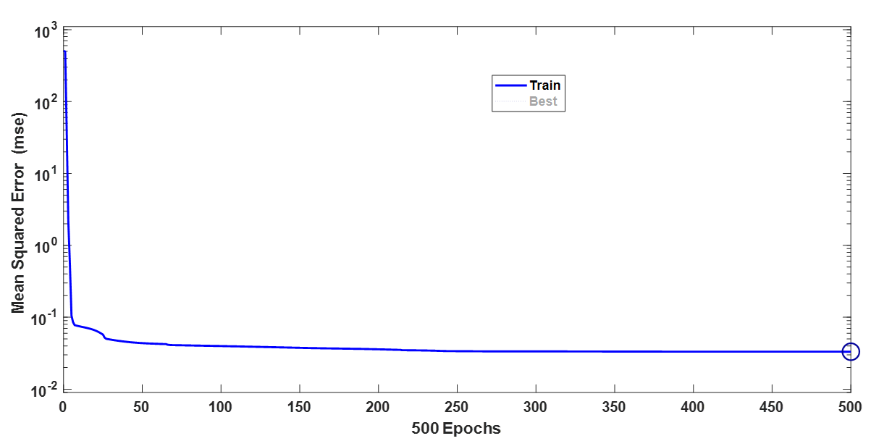

Figure :Elman neural network training error versus epochs

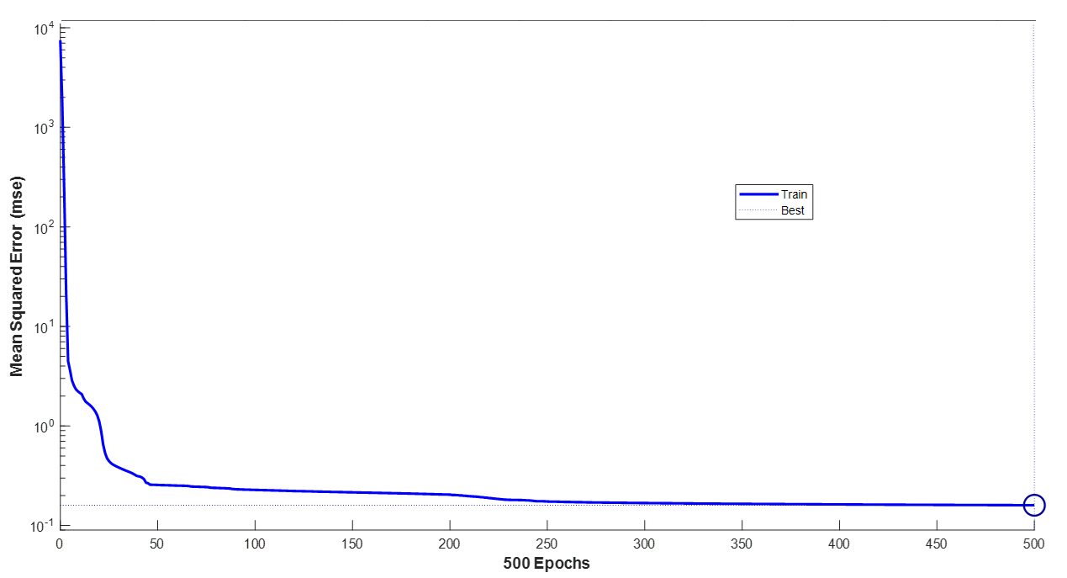

Figure :Jordan neural network training error versus epochs

4057

Table 2:The obtained results of applying various Jordan and Elman network training methods

|  |  |  |  |
| --- | --- | --- | --- |
| RMSE for Elman net | RMSE for Jordan net | Training Algorithm | Row |
| 47.6957 | 38.0257 | Levenberg Marquardt | 1 |
| 54.7495 | 32.7285 | Bayesian Regularization | 2 |
| 40.8700 | 42.3425 | Scaled Conjugate Gradient | 3 |
| **28.3561** | 38.9066 | **The Resilient** | 4 |
| 42.2816 | 79.0576 | One Step Secant | 5 |
| 48.9405 | 46.4170 | Gradient Descent with Momentum and Adaptive Learning Rate | 6 |
| 62.5275 | **16.2796** | **Gradient Descent with Adaptive Learning Rate** | 7 |
| 53.5448 | 44.2533 | Conjugate Gradient with Polak-Ribiere Updates | 8 |
| 40.7618 | 45.1409 | Conjugate Gradient with Fletcher-Reeves Updates | 9 |
| 46.5287 | 45.8523 | Conjugate Gradient with Powell-Beale Restarts | 10 |
| 54.3545 | 61.1783 | BFGS Quasi-Newton | 11 |

****

Figure :Exhaust valve temperature prediction using Elman and Jordan Nets

4058

**Conclusion**

In this study, feedback neural networks namely Elman and Jordan are used for estimation of engine exhaust valve temperature using seat temperature and thermal contact conductance between exhaust valve and seat. Input and output data are extracted using and experimental study on thermal analysis of an air cooled single cylinder internal combustion engine. Inverse method using Adjoint problem is used for calculation of thermal contact conductance between exhaust valve and seat using thermocouple temperature data located in determined positions in seat and exhaust valve. Different training algorithms are trained for Jordan and Elman networks. The results showed that both of Elman and Jordan networks have the ability of prediction the temperature of the exhaust valve in internal combustion engines. However, Jordan neural networks with Gradient Descent with Adaptive Learning Rate training method presented the best results with RMSE error of 16.3.

**Conflict of interests**

There is no conflicting interest for the publication of this manuscript.

**Abbreviations**

4059

|  |  |
| --- | --- |
| CFD | Computational Fluid Dynamics |
| FVM | Finite-Volume Method |
| GMDH | Group Method of Data Handling |
| $$h(t)$$ | Thermal contact conductance |
| k | Thermal conductivity |
| MAF | Moving Average Filter |
| MLP | Multi-Layer Perceptron |
| q | Heat flux |
| RMSE | Root Mean Squared Error |
| S | Stop criterion |
| T | Temperature |
| t | Time |
| TCC | Thermal Contact Conductance |
| TCR | Thermal Contact Resistance |
| TiC | Titanium Carbide |
| TiN | Titanium Nitrite |
| Y | Measured temperatures |

**Reference**

|  |  |
| --- | --- |
| [1] | M. A. S. Mohamed Hassan, Z. Mohamad Razlan, S. Abu Bakar, M. Afendi Rojan, W. K. Wan Ahmad, Z. Ibrahim, A. Ishak, A., A. Abdul Rahman and M. R. Mohd Jamir, "Approach to enhance the heat transfer of valve seats through," Applied Thermal Engineering, vol. 202, no. 117870, pp. 1-19, 2022. |
| [2] | M. Cerdoun, S. Khalfallah, A. Beniaiche and C. Carcasci, "Investigations on the heat transfer within intake and exhaust valves at various engine speeds," International Journal of Heat and Mass Transfer, vol. 147, no. 119005, pp. 1-12, 2020. |
| [3] | M. H. Shojaefard, A. R. Noorpoor, D. A. Bozchaloe and M. Ghaffarpour, "Transient thermal analysis of engine exhaust valve," Numerical Heat Transfer, Part A, vol. 48, p. 627–644, 2005. |
| [4] | M. Cerdoun and C. G. A. Carcasci, "Analysis of unsteady heat transfer of internal combustion engines’ exhaust valves," International Journal of Engine Research, p. 1–18, 2017. |
| [5] | C. S. Prasad, M. Babu and S. Sachin Raj, "Thermal analysis on exhaust valve with thermal barrier material," International Research Journal of Automotive Technology (IRJAT), vol. 1, no. 6, pp. 18-32, 2018. |
| [6] | H. Abdollahi, S. . Shahraki and M. Motahari-Nezhad, "A review on the effects of different parameters on contact heat transfer," Thermophysics and Aeromechanics, vol. 24, no. 4, 2017. |
| [7] | M. H. Shojaeefard, V. K. Mousapour and M. S. Mazidi, "The investigation of the effect of contact frequency upon thermal contact conductance," International Journal of Automotive Engineering, vol. 4, no. 1, 2014. |
| [8] | M. Motahari-Nezhad and A. Rahi, "Sensitivity analysis of different parameters affecting thermal contact conductance," International Journal of Automotive Engineering, vol. 8, no. 4, p. 2908, 2018. |
| [9] | M. A. S. M. Hassan, A. B. Shahriman, Z. M. Razlan, N. S. Kamarrudin, W. K. N. Khairunizam, M. S. M. Hashim, A. Harun, I. Ibrahim, I. Azizul Aziz, Z. Ibrahim, M. K. Faizi, M. F. H. Rani, A. Rahman, M. F. H. M F H Rani, M. A. Rojan and R. Mura, "Engine performance analysis by studying heat transfer in the valve seat through steady-state thermal simulation," Journal of Physics: Conference Series, vol. 2129, pp. 1-6, 2021. |
| [10] | M. Motahari-Nezhad, M. H. Shojaeefard and S. Shahraki, "Studying the transient thermal contact conductance between the exhaust valve and its seat using the inverse method," International Journal of Thermophysics, vol. 37, no. 13, pp. 1-25, 2016. |
| [11] | M. A. S. M. Hassan, A. B. Shahriman, Z. M. Razlan, N. S. Kamarrudin, I. A. Aziz, W. Khairunizam, M. S. M. Hashim, A. Harun, I. Z. I Ibrahim, M. K. Faizi, M. F. H. Rani and R. Murali, "Engine performance enhancement by improving heat transfer in between exhaust valve and valve seat through CFD (transient thermal) simulation," AIP Conference Proceedings, vol. 2339, 2021. |
| [12]  4060 | M. A. R. S. Al-Baghdadi, S. S. Ahmed and N. A. Ghayadh, "Mechanical and thermal stresses analysis in diesel engine exhaust valve with and without thermal coating layer on valve face," International Journal Of Energy And Environment, vol. 7, no. 3, pp. 253-262, 2016. |
| [13] | M. Cerdoun, S. Khalfallah and C. Carcasci, "Investigations on the heat transfer within intake and exhaust valves at various engine speeds," International Journal of Heat and Mass Transfer, pp. 1-12, 2020. |
| [14] | R. S. Rao, K. H. Reddy and C. R. V. Kumar, "Simulation of composite Titanium Nitrite (TiN) coated Internal Combustion engine exhaust valve using ANSYS," International Journal of Recent Technology and Engineering (IJRTE), vol. 8, pp. 626-631, 2019. |
| [15] | B. Pavel and D. Ales, "The simulation calculation of temperatures on valve seats of combustion engine and its verification," Advanced Materials Research, vol. 1016, pp. 577-581, 2014. |
| [16] | M. Mohsen Motahari-Nezhad and M. S. Mazidi, "An adaptive neuro-fuzzy inference system (ANFIS) model for prediction of thermal contact conductance between exhaust valve and its seat," Applied Thermal Engineering, vol. 105, pp. 613-621, 2016. |
| [17] | S. Fathi, M. E. Yazdi and A. Adamian, "Comparison of neural networks and fuzzy system for estimation of heat transfer between contacting surfaces," The Journal of Advanced Design and Manufacturing Technology (ADMT), vol. 12, no. 2, pp. 91-101, 2019. |
| [18] | K. Goudarzi, A. Moosaei and M. Gharaati, "Applying artificial neural networks (ANN) to the estimation of thermal contact conductance in the exhaust valve of internal combustion engine," Applied Thermal Engineering, vol. 87, pp. 688-697, 2015. |
| [19] | Z. C. Lipton, J. Berkowitz and C. Elkan, "A critical review of recurrent neural networks for sequence learning," Computer Science, 2015. |

4061